SDA Wallet Design Contest

Works Upload Processes

Link to SD Wallet Design Contest repositoriy: <https://github.com/SDChain/SDA_Wallet_Design_Contest>

1. Click “Fork” to fork SDA_Wallet_Design_Contest to your GitHub account.

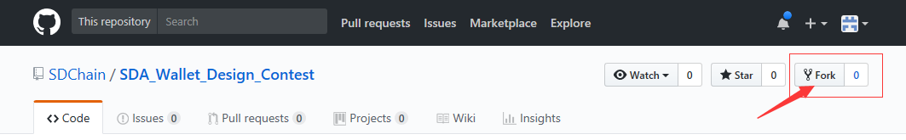

2. Create a folder to upload your works, use your account name as folder name.

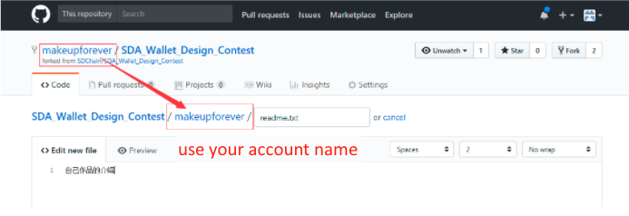

3. Click “Commit new file”

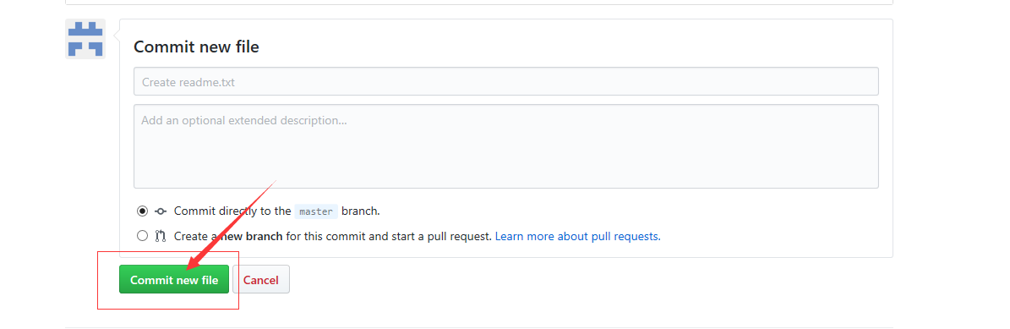

4. Click “Upload files”, upload your works.

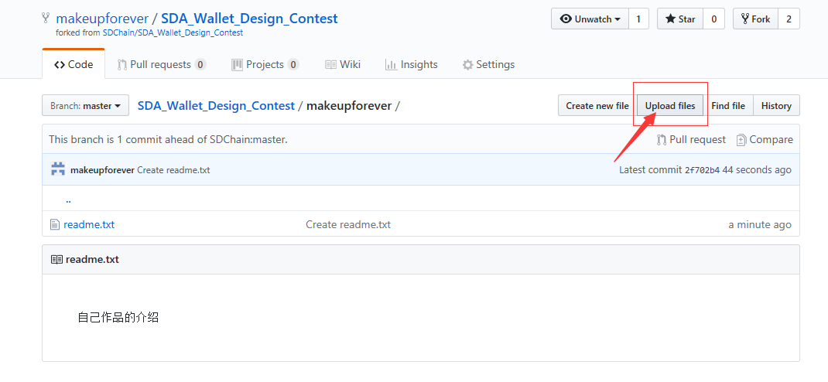

5. Click “Pull request”

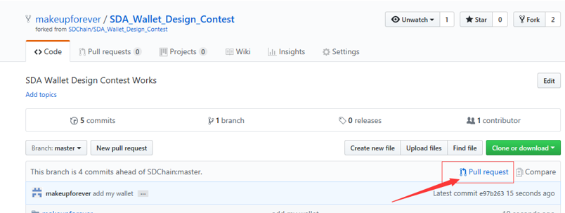

6. Click “Create pull request”

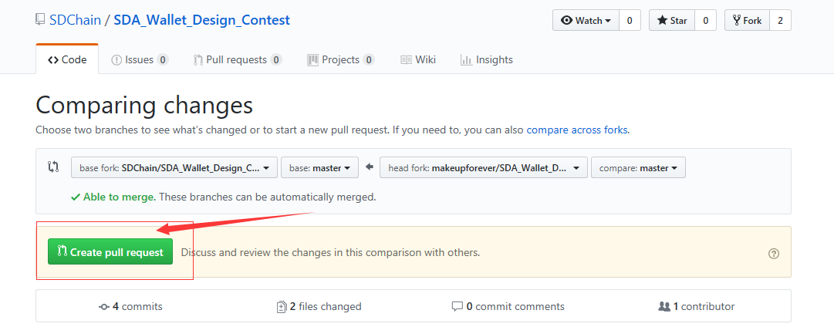

7. Use your name + ‘s works as title.

8. Click “Create pull request” to finish your submission.

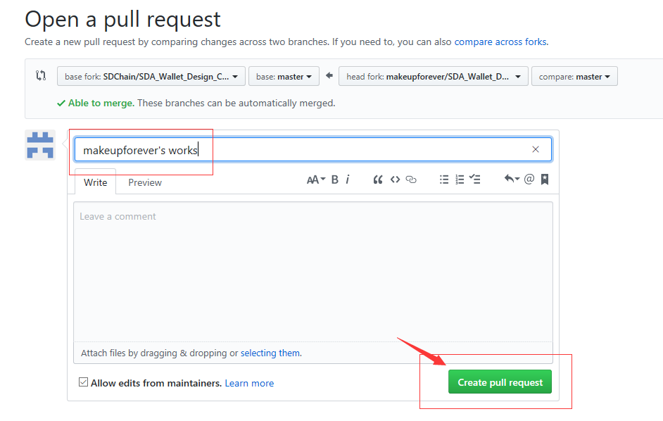

9. Your works will appear in SDA_Wallet_Design_Contest repositoriy once it’s reviewed by the committee.

